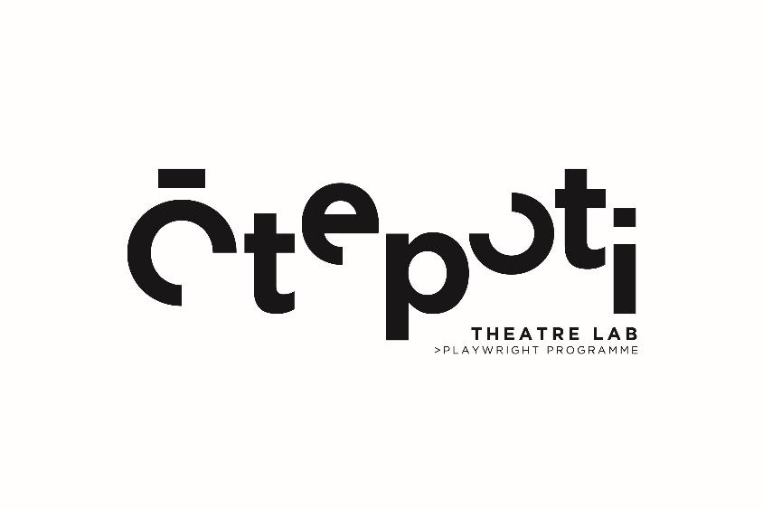

Frequently Asked Questions

What is the Playwrights Programme?
The Ōtepoti Theatre Lab Playwrights Programme is an opportunity for 3 local (Ōtepoti Dunedin region) emerging playwrights to develop a short theatre script with the support of an experienced dramaturg (script advisor–mentor). At the end of the 10-week programme, each script is presented by professional actors at the public reading.

Am I an Emerging Writer?
The definition of Emerging Writer is pretty wide and flexible. As long as you’re not already having regularly produced, highly–successful plays staged in Aotearoa NZ (and if you are, well done!), we will most likely consider your application.
Some scenarios:
- ‘I’ve worked in theatre for a long time as an actor/stage manager/direct, but never as a writer.’
– YES, you can apply!
- ‘I’ve been part of similar development programmes before and have had a show or two staged as part of Fringe Festivals.’
– YES, you can apply!
- ‘I’ve been writing informally for years and would love to know if my idea would translate well to stage.’
– YES, you can apply!
- ‘I’ve never worked in theatre, but love to write.’
– YES, you can apply!

What do I need to Apply?
Full details are available in our application pack (available 1st May) but here’s the gist:
- An idea for a short play (any style or genre) with no more than 4 characters.
- Brief bio info and statement around what why you’d be a good Playwrights Programme candidate.
- A writing sample.
That's it!

Is there a Cost?
The Playwrights Programme is FREE for the 3 successful playwrights. We will even pay you a stipend to give you some extra support while you work on your project.
Ōtepoti Theatre Lab covers the cost of the professional dramaturgs, directors, and actors you get to work with.

What’s the Process?
Great question! Here’s the Playwrights Programme process in a nutshell:
Applications open at the beginning 1st of May 2023. The deadline for applications is 1st June 2023.
Early July, we’ll announce the successful 3 playwrights for 2023. Then we match each writer with the best dramaturg (script advisor mentor) and presenting team (director and actors) for their project. It’s critical to us that we get this right, so we take special care to surround you with who you need.
The 10-week Playwrights Programme starts officially in early August with a group orientation session for the 3 playwrights. Then the mahi really begins; you’ll work with your dramaturg in the way that best suits you. This could be via Skype, Zoom, over coffees, or something more formal.
Over the course of the programme, you’re expected to complete 3 drafts of your script. The 2nd draft is for a closed-group reading, and the 3rd draft is your workshop–rehearsal public reading version.
Meanwhile, our team will be busy in the background, making sure you have a great director, professional actors, and the resources you need to bring your 10-15 minute piece to reality. We’ll arrange your workshop and rehearsal time, and schedule and promote the public readings.
We’ve carefully designed this programme to include both group sessions as well as the individualised mentoring. If you’d like to connect with other writers during or after the programme, see below under Further Opportunities for information about the Ōtepoti Writers Lab sessions.
Every decision we make during the Playwrights Programme is to develop, share, and celebrate you and your work in the best, most supportive, and appropriate way. That’s how we develop strong writers and their work and is at the heart of what we do.

When are the Public Readings and who can attend?
The public readings for 2023 will be held in late October 2023.
The public readings are ticketed but they are FREE to make them as accessible as possible for people to attend.

Are there Further Opportunities for me and my work?
If you’d like to connect more informally with writers of all genres, mediums, and stages of experience, you might consider our FREE fortnightly Ōtepoti Writers Lab sessions.
There’s many ways we can ensure that your work has a future beyond the programme, whether through dramaturgical services or mentoring, assisting you to approach and prepare for festivals, or connecting you with other companies/individuals in our extensive networks. We also offer at least one work from each cycle the chance to undergo further develop or receive production assistance from our company, Prospect Park Productions NZ.
The Playwrights Programme can be a fantastic stepping stone for those wanting to work in theatre. Past writers have gone on to have full-length productions and successfully applied for postgraduate courses such as the Master of Creative Writing at The International Institute of Modern Letters. Whatever you do next, Ōtepoti Theatre Lab Playwrights Programme is where you will learn invaluable writing development skills, make great industry connections, and create some unforgettable theatre-making memories.

Contact Us
Please don’t hesitate to contact us with any other questions you may have that aren’t answered here – email h-j@prospectpark.co.nz.

Keen to apply?
Download the application pack at https://www.prospectpark.co.nz/playwrights-programme.

Applications close midnight 1st June 2023

