Ōtepoti Writers Lab Code of Conduct

Mission and Values
The purpose of the Ōtepoti Writers Lab [ŌWL] Code of Conduct is to encourage diverse, inclusive, and safe participation in writing sessions for all members. The Code extends to everyone in the ŌWL community, including facilitators and participants. The Code applies to in-session time as well as ŌWL-related events and interactions outside the formal sessions.

Kaupapa
Central to ŌWL’s Kaupapa is to foster and encourage creative, daring, and truthful expression through writing. This is to be upheld in balance with the principle that sessions be as accessible and inclusive as possible.

The Code

Our Community
We recognise and respect that ŌWL members represent a range of ages, backgrounds, beliefs, and communities.

Everyone is equally welcome in ŌWL sessions.

We place equal importance on celebrating members’ writing achievements as we do support and acknowledging members who are facing barriers in their work, where and when appropriate.

All ŌWL members have valued contributions to make, no matter their writing experience, training level or degree, professional profile, or accolades and awards.

Writing is a process and a practice. Writers take many and varied journeys and reach different destinations. ŌWL supports and values all writers regardless the pace, distance, or regularity of their practice.

Someone who attends ŌWL once a year is just as welcome as someone who can and wants to attend every session.

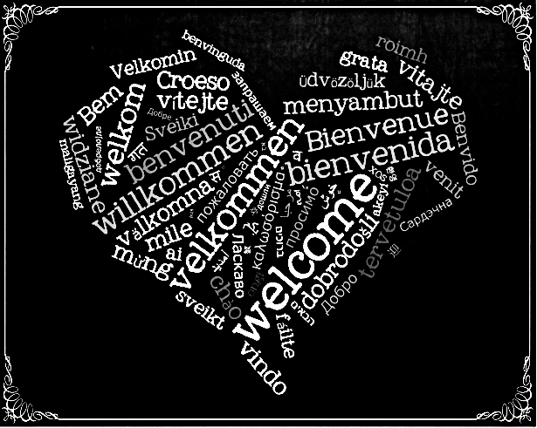

Conduct in Session
ŌWL is a shared space for writing.

ŌWL facilitators and members collectively encourage participation in the sessions.

We respect each other’s writing practice and space during the allocated time(s) in session.

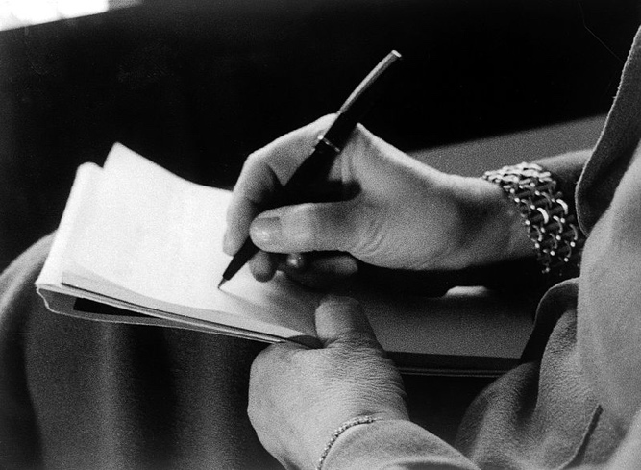

Members share their writing and ideas for the group alone. Unless a member explicitly grants permission, their work and any related discussion stays within the session.

Sharing and Feedback
We respect members’ choice to share or not share their work or contribute to discussions.

It is the individual writer’s choice whether to share their work and/or seek and accept feedback.

In offering feedback, we are aware that tone of voice, the words we use, and our body language can impact how critique is received.

We focus critique on the work, not the writer. We are considerate of both the writer and their work. Disagreement is acceptable, but it must be respectful.

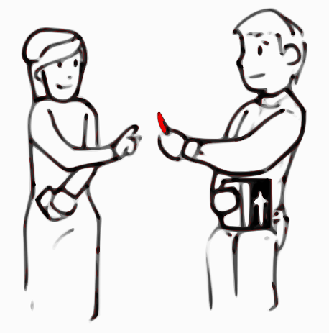

Community Safety
We support the choice of members to excuse themselves for some or the remainder of a session in the interests of their wellbeing.

We endeavour to flag sexual, violent, and/or adult-oriented content in our writing before sharing.

We abstain from sending hostile, rude, or obscene messages to any individual or group within the ŌWL community.

We have zero tolerance for sharing materials (text, images, or audio) that encourage violence or hatred based on race, ethnic origin, religion, disability, gender, age, or sexual orientation, or that encourages others to injure themselves, embrace eating disorders, or suicide, rather than seeking counselling or supportive conversation.
Process for Handling Complaints and Concerns
Where and when possible, complaints and concerns should be addressed to the session facilitator in the first instance.

If you are not comfortable or able to raise your concerns with the facilitator, then you can contact H-J Kilkelly.
Email: h-j@prospectpark.co.nz

All community members are entitled to have a support person or persons in attendance in any discussions related to the ŌWL Code of Conduct.

